Image Generation using Variational Autoencoders

An essential hindrance caused by the autoencoders in image generation is that there is no conventional distribution of the data i.e., distribution of the data is uncertain resulting in inadequate formation of images.
The Variational Auto-encoder endures the complication by attaining a
probability distribution called Gaussian distribution. Unlike autoencoder, variational autoencoder attempts to map each of an input image to a multivariate gaussian distribution about a point in a latent vector space.
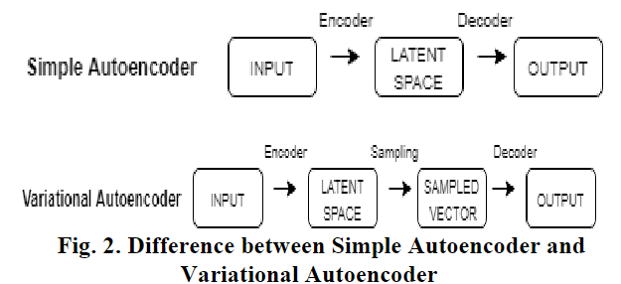

A. Orthogonal Variation

Dimensionality reduction is the obligatory technique while dealing with image datasets. There are a number of dimentionality reduction algorithms like multidimensional scaling, PCA, t-Distributed Stochastic Neighbor Embedding, linear discriminant analysis and many more. Principal component analysis is the predictable and traditional dimentionality reduction technique implemented in machine learning and deep learning applications.
The prevalent orthogonal transformation used in PCA convert higher dimensional set of features into lower dimensional vectors i.e., linear composition of corresponding variables into uncorrelated variables.

- Fuzzy Image Formation

Auto encoders are comprehensible neural network structures that avails backpropagation and are trained through the fundamental miscellaneous algorithms from Restricted
Boltzmann Machines to more standard traditional techniques like stochastic gradient descent. Besides the activation function, autoencoder and PCA are analogous to each other
[4]. Typically, autoencoders exploit non-linear activation functions like Rectified linear unit and sigmoid functions. Activation function potentially used by the encoders are given
by,
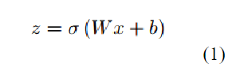
Correspondingly, the decoder takes the output of the encoder and decodes the image using the following equation,
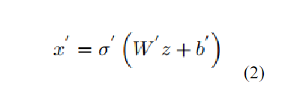
The loss function required to train the autoencoders through standard backpropagation mechanism is given by,
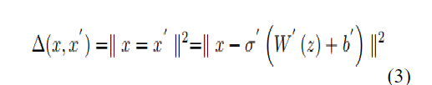
(3)
However, discontinuity and discrete latent space resulted in obscure image formations.

C. Perpetual Latent Space
Unlike autoencoder, the primitive isolated property of variational autoencoder is the continuous latent space that permits easier interpolation i.e., the decoder confirms that the
points residing in the same community produce similar images. The probability distribution allows encoder to output a vector of two variables i.e., mean and standard deviation vectors which help in data modelling [6]. Thus, it generates lucid images by sampling the distribution.

PROPOSED METHOD

The unsupervised learning used for the given problem is Variational Autoencoder commonly known as VAE. Initially variational autoencoder encodes the given input and maps it to a mean and a variance vector. The point is then sampled from this probability distribution and is decoded to evaluate the reconstruction error. Due to the gaussian distribution, VAE generates flattened depiction of input. The correlation does not exist between any two dimensions and hence the covariance matrix configured is diagonal. The logarithm of the variance ranges from (-∞,∞) and the value of epsilon is sampled from normal distribution. The point z in the latent space is produced from the following equation,

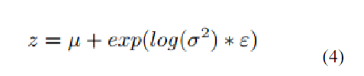

A convolutional layer is a building block of a convolutional neural network (CNN) that extracts features from images. It's a filter that slides over an image to identify features and produce feature maps.
The shape of a convolution layer input will be (c, h, w) (or (h, w, c) depending on the framework) where c is the number of channels, h is the width of the input and w the width. You can see it as a c-channel hxw image. All pixels of that input, the values on each channel gives additional information on that pixel. Having three channels will give each pixel ('pixel' as in position in the 2D input space) a richer content than having a single. Since each pixel will be encoded with three values (three channels) vs. a single one (one channel).
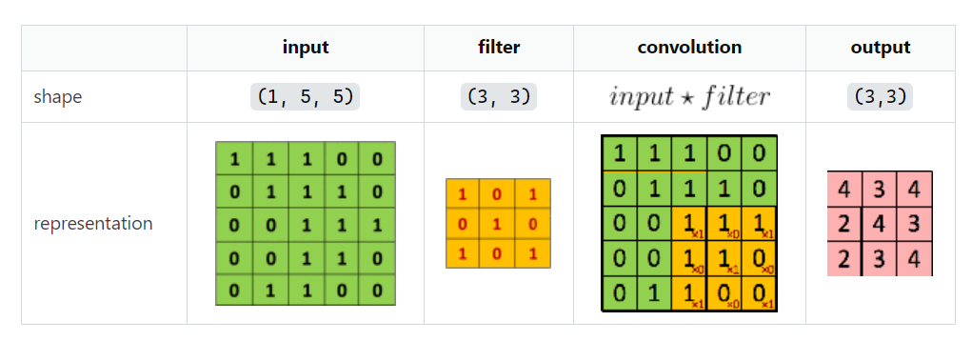
The Encoder
The implementation of encoder uses 4 piled convolutional 2D layers sequentially followed by Leaky RELU activation function. The Leaky RELU used here is to implant dying RELU problem encountered [8]. These convolutional 2D layers incorporated with odd filters are applied to the designated input to originate a feature map. They capture progressive exemplary features of input. After every single convolutional layer [9], batch normalization technique is implemented to regulate, fine-tune and scale parameters in order to accelerate the learning process. Eventually, the last layer is flattened and coupled with the dense layers of mean and log variance to generate two-dimensional latent space.
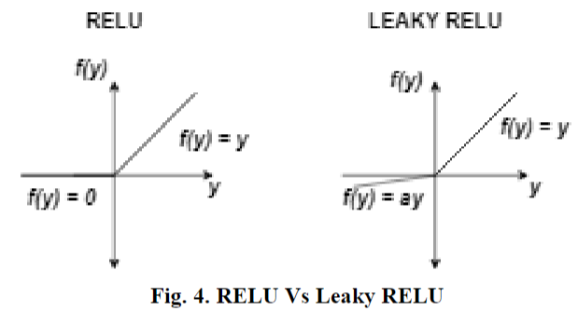
The Decoder
The decoder attains the reshaped tensor from the encoder and comprises 4 stacked convolutional transpose layers. These layers perform up-sampling in an optimal pattern and contain reasonable weights. Rear layers adhere with fully connected i.e., the dense layers and decodes it into the primary image domain.
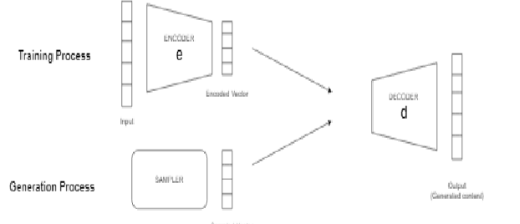

The Loss
Variational autoencoders follow a particular category of loss function called Kullback-Leibler divergence, popularly known as KL divergence [10]. KL divergence estimates the divergence between any two probability distributions. KL divergence contracts the information loss while dealing with imprecise distributions [11]. Hence KL loss is directly proportional to mean and log variance i.e., loss becomes 0 when mean and log variance reaches to 0. The loss function used is the combination of KL divergence loss and reconstruction loss which is measured using r_loss_factor. The key factor to note is that by increasing the reconstruction loss [12], the regulatory consequence of KL loss decreases and by reducing the reconstruction loss, we acquire poorly formed images.
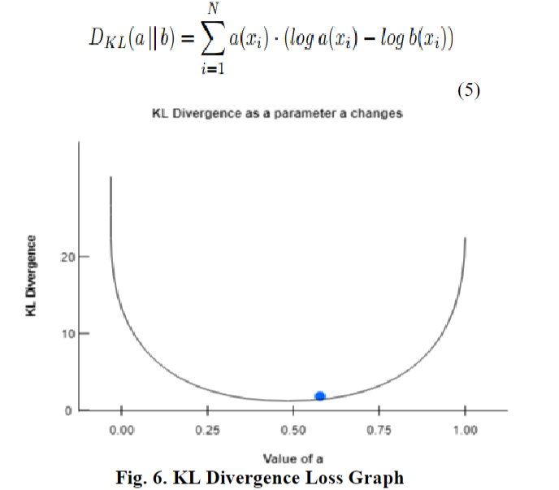

Training and Evaluation
Distribution of Points- Contrary to standard autoencoder, variational autoencoder follows a probability distribution called normal distribution. The impact of KL divergence decreases if the dimensions significantly differ from standard normal distribution. Hence to make them identical, the reconstruction loss has to be minimized.
Training Details- The reconstruction loss is implemented using mean squared error and KL loss is computed at the end. The aggregate loss obtained is determined by taking the average of reconstruction and KL loss values. The optimizer used during the compilation process is Adam with a learning rate of 0.0005. Ultimately, the model was trained for 30 epochs with a batch size of 150.
Latent Space Arithmetic- Arithmetic operations on vectors can be computed after encoding the given input. Latent space arithmetic aids in converting one type of attribute into another i.e., distinct versions of faces can be formed with a relevant variation in feature. Vector arithmetic in latent space can be calculated using the expression given below
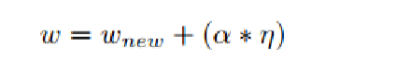
Referrence: https://www.researchgate.net/publication/344224573_Image_Generation_using_Variational_Autoencoders

